Using the Set Operators & Displaying Data from Multiple Tables Using Joins

Question 1
Create a matrix query to display the job, the salary for that job based on department number, and the total salary for that job, for departments 10, 20, and 30, giving each column an appropriate heading.
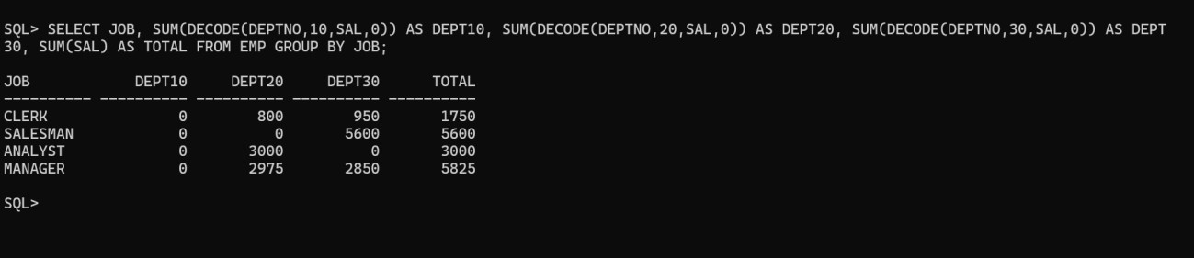
Output:

Question 2
Using set operator display the DEPTNO, SUM(SAL) for each dept, JOB, SUM(SAL) for each Job and Total Salary.

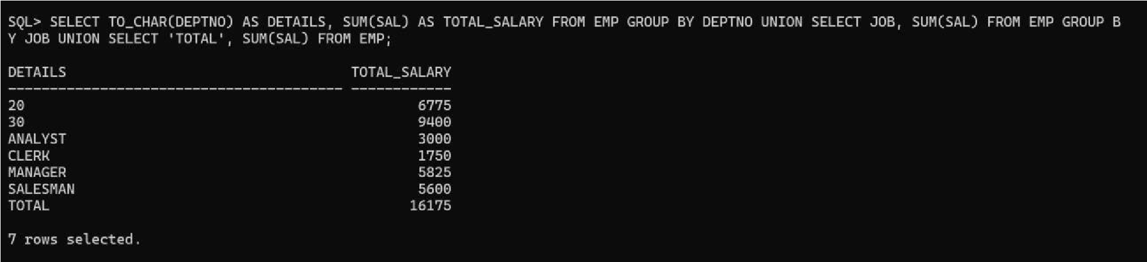
Output:

Question 3
Using Set Operator display the JOB and Deptno in employees working in deptno 20,10,30 in that order.
Output:
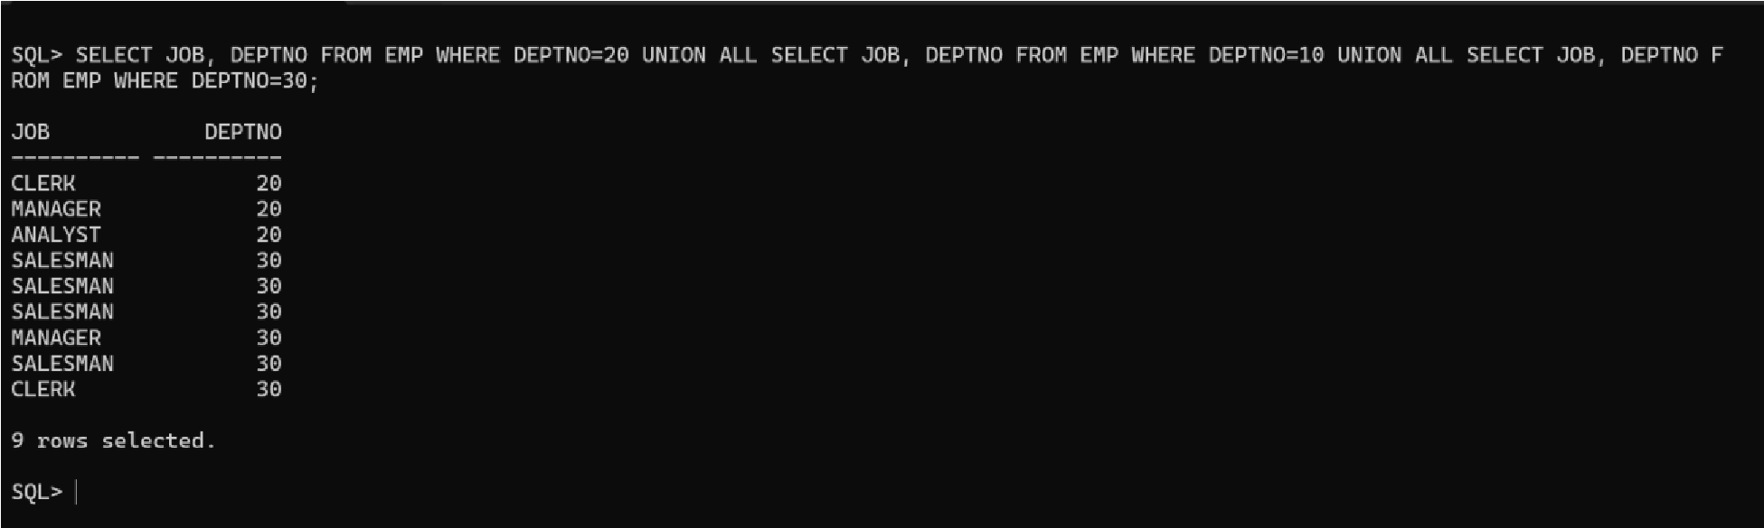

Displaying Data from Multiple Tables Using Joins
Question 1
Write a query for the HR department to produce the addresses of all the departments. Use the
EMP and DEPT tables. Show the EMPNO, ENAME, SAL, DNAME and LOC in the output. Use a NATURAL JOIN to produce the results.
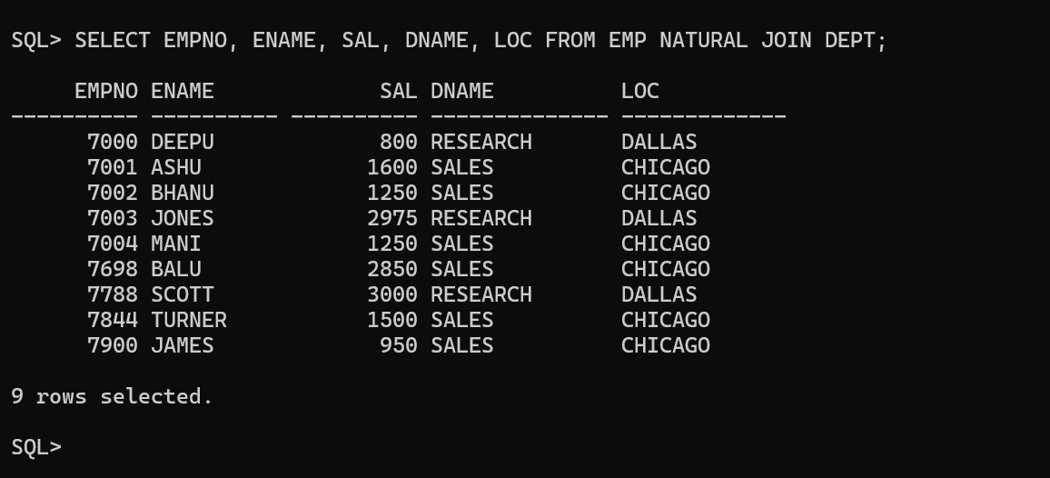
Output
:

Question 2
The HR department needs a report of all employees. Write a query to display the JOB, MGR, SAL, COMM, DNAME of employees whose JOB is SALESMAN.
Output:
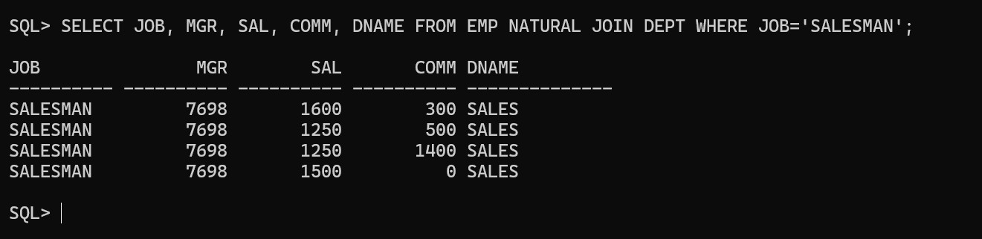

Question 3
The HR department needs a report of employees in LOC DALLAS. Display the ENAME, job, DEPTNO, and DNAME for all employees who work in DALLAS.
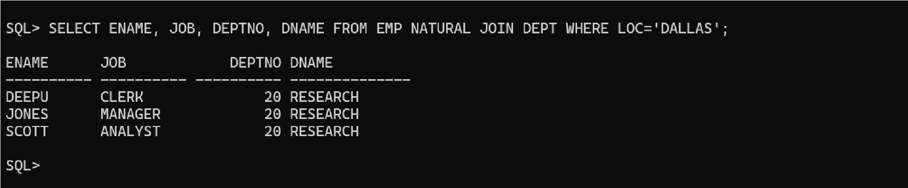
Output:

Question 4
Create a report to display employees' ename and employee number along with their manager's name and manager number. Label the columns Employee, Emp#, Manager, and Mgr#, respectively.
Output:
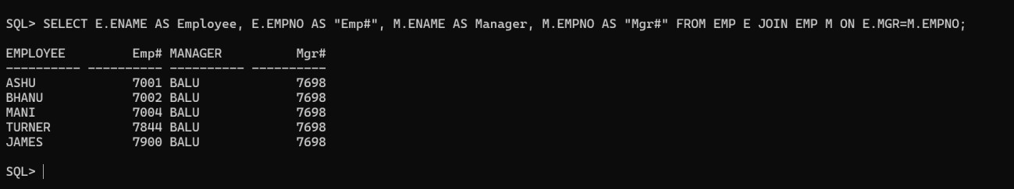

Question 5
Modify the previous Query to display all employees including King, who has no manager. Order the results by the employee number.
Output:
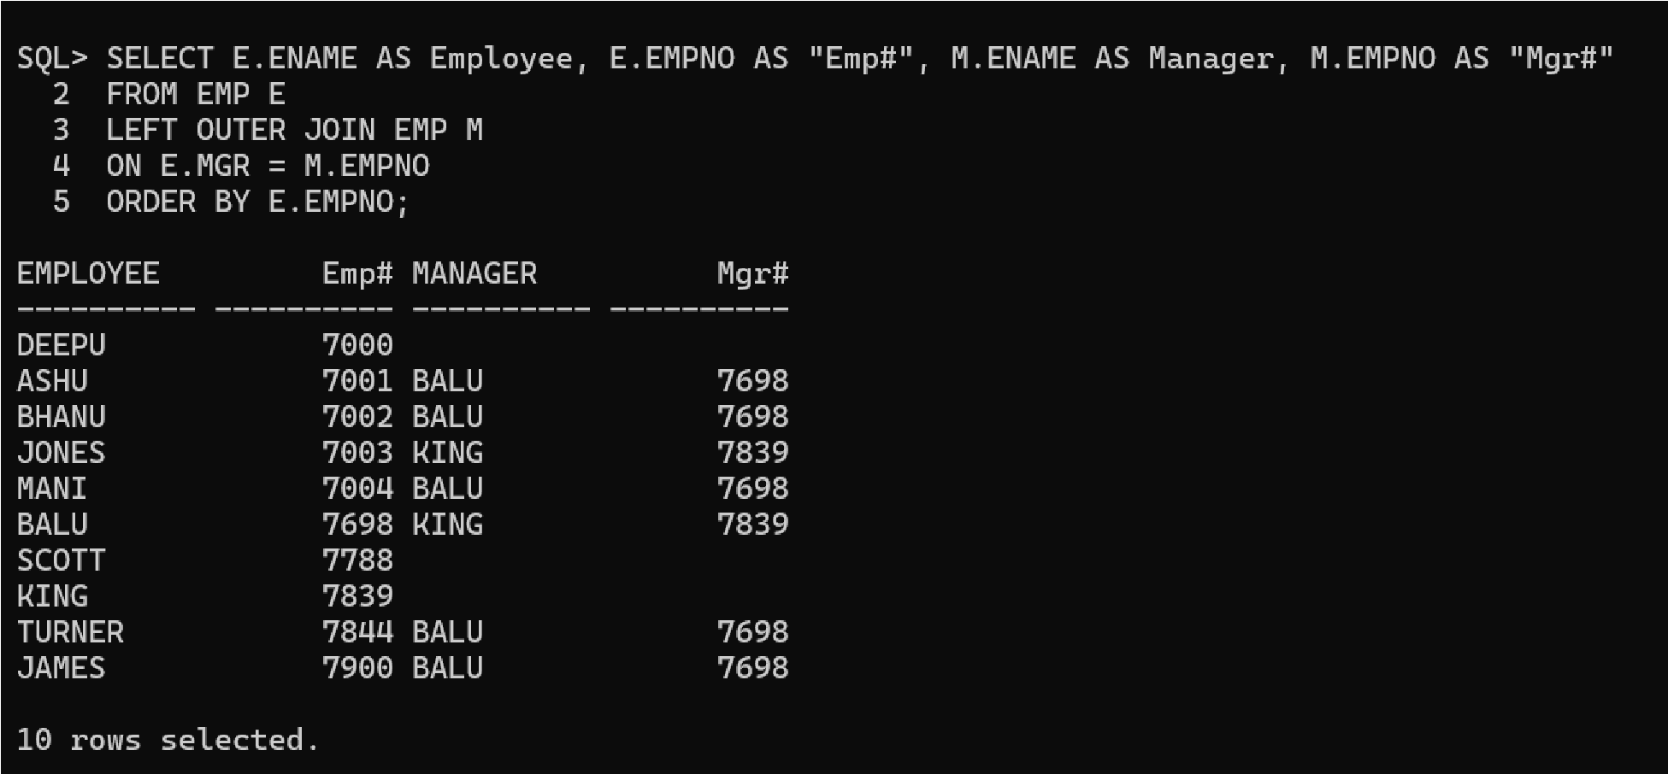

Question 6
The HR department needs a report on job grades and salaries. To familiarize yourself with the SALGRADE table, first show the structure of the SALGRADE table. Then create a query that displays the name, job, department name, salary, and grade for all employees.
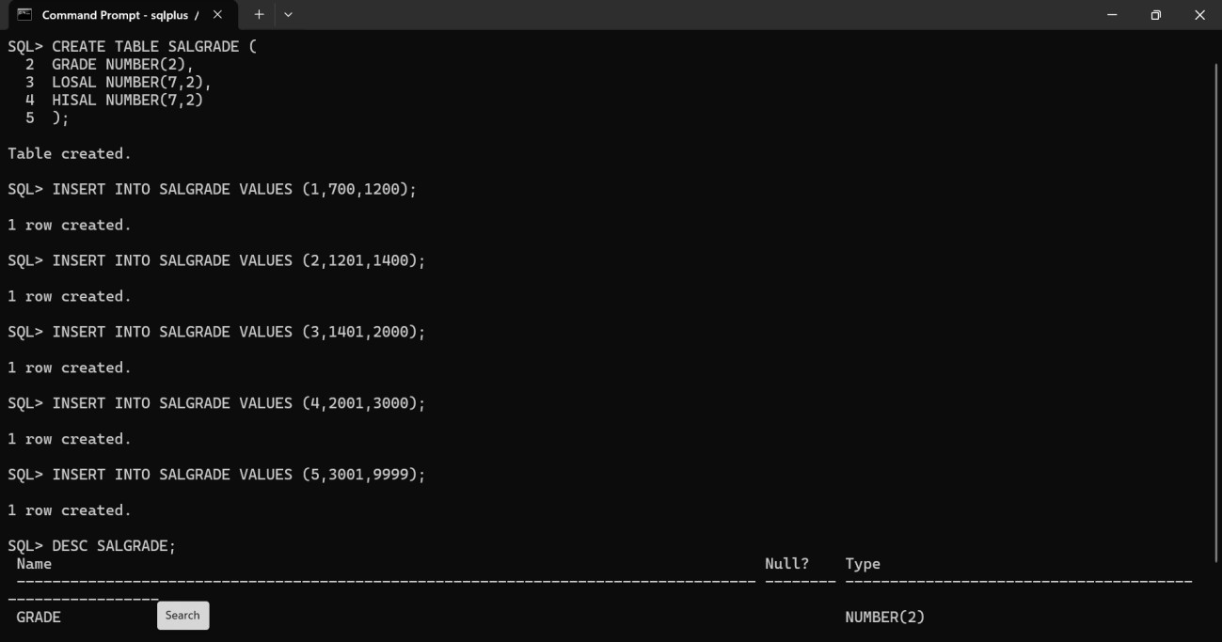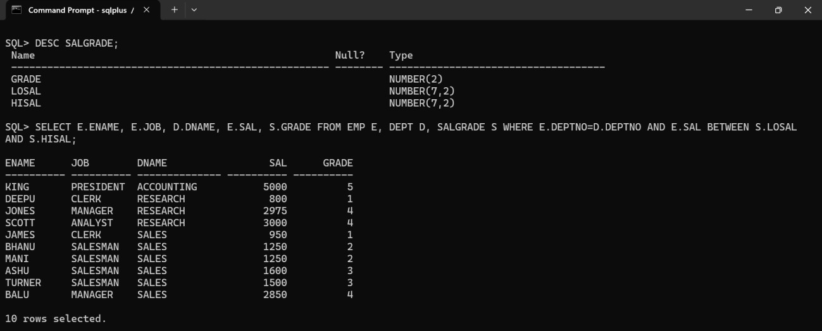
Question 7
Display the ENAME, DNAME of all the employees. Also display those department name which do not have any employees working.
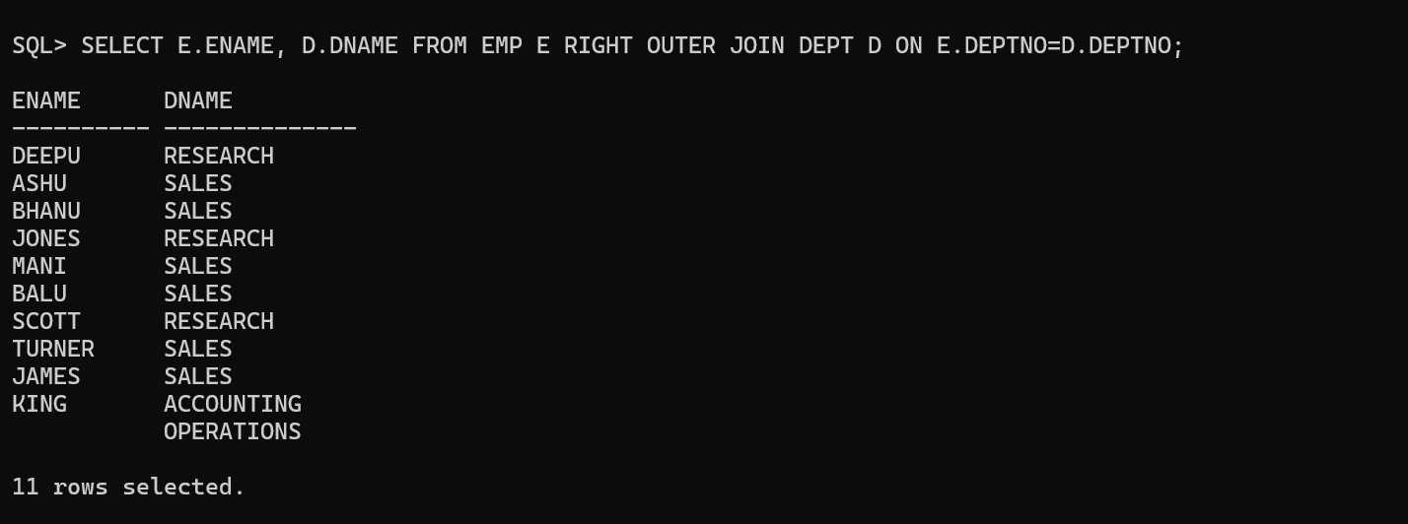
Output:

Question 8
The HR department needs to find the names and hire dates for all employees who were hired before their managers, along with their managers' names and hire dates.
Output:
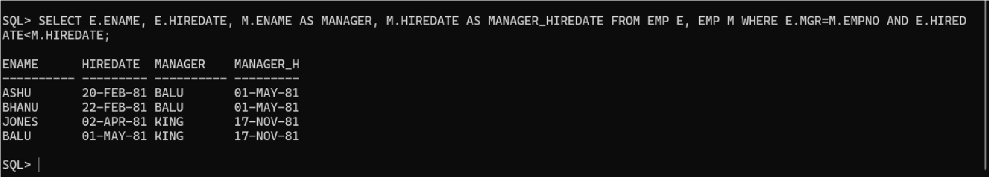
Question 9
Display the EMPNO, ENAME, DNAME, LOC of those employees who are working as CLERK. Use the USING clause.
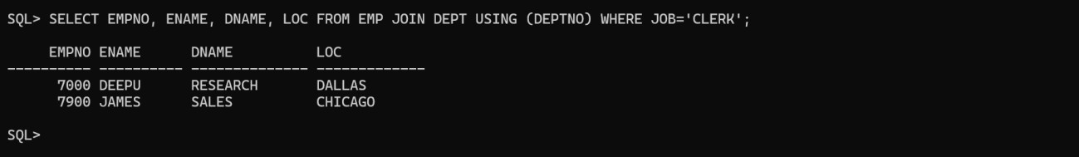
Output:

Question 10
Display the ENAME, SAL, MGR, DNAME of employees whose salary is more than 2000. Use the ON clause.
Output:
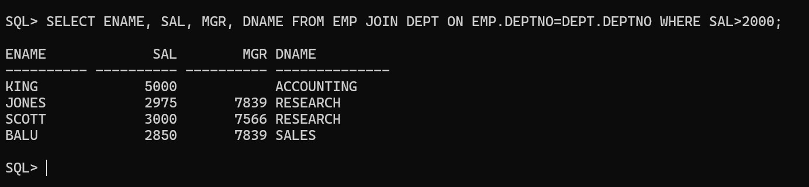

Question 11
Display the EMPNO, ENAME, JOB, DEPTNO, DNAME, LOC of employees. Use LEFT OUTER JOIN.
Output:
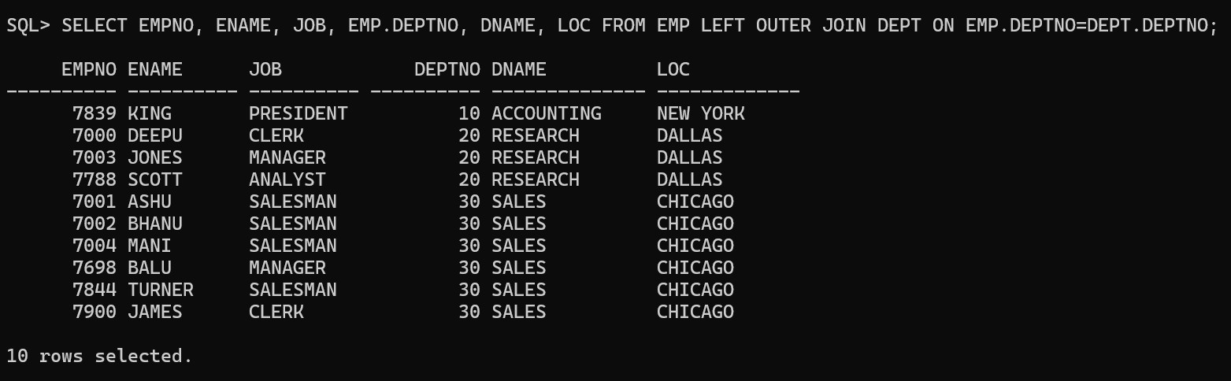

Question 12
Display the ENAME, DNAME of employees. Use RIGHT OUTER JOIN.
Output:
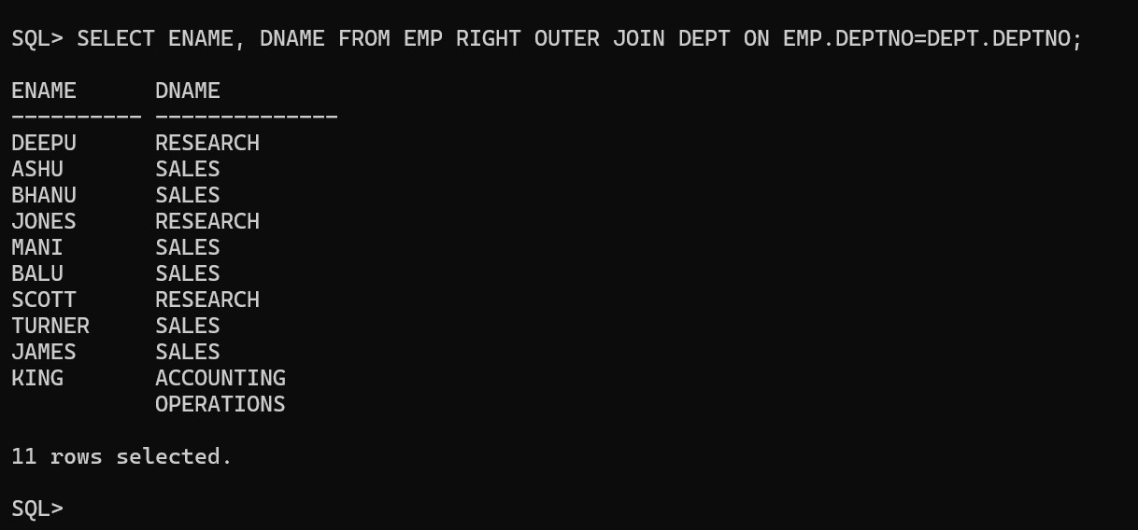

Question 13
Display the EMPNO, DNAME, LOC of employees. Use FULL OUTER JOIN
Output:
